HOSPITAL DATABASE MANAGEMENT SYSTEM

PL/SQL COMMAND:

create table patient (

pat_id varchar2(10 CHAR),

pat_name varchar2(60 CHAR),

pat_gender varchar2(2 CHAR),

pat_address varchar2(100 CHAR),

pat_number number(11,0),

pat_doc_code varchar2(10 CHAR),

constraint pk_patient primary key (pat_id),

constraint uq_doc_code unique (pat_doc_code)

);

create table patient_diagnosis(

Diag_ID varchar2(10 CHAR),

diag_details varchar2(200 CHAR),

diag_remarks varchar2(200 CHAR),

diag_date date,

pat_id varchar2(10 CHAR),

constraint pk_patient_diagnosis primary key (diag_id),

constraint fk_pat_id foreign key (pat_id)

references patient(pat_id)

);

create table doctor(

doc_code varchar2(10 CHAR),

doc_name varchar2(60 CHAR),

doc_gender varchar2(2 CHAR),

doc_address varchar2(200 CHAR),

doc_designation varchar2(30 CHAR),

doc_number number(11,0),

constraint pk_doctor primary key (doc_code),

constraint fk_doc_code foreign key (doc_code)

references patient(pat_doc_code)

);

create table bill(

bill_no integer,

pat_id varchar2(10 CHAR),

pat_name varchar2(60 CHAR),

pat_gender varchar2(2 CHAR),

pat_address varchar2(100 CHAR),

doc_name varchar2(60 CHAR),

amount NUMBER(19,9),

constraint pk_bill primary key (bill_no),

constraint fk_bill_pat_id foreign key (pat_id)

references patient(pat_id)

);

INSERT INTO PATIENT VALUES ('P001','Raghav Sharma','M','#33, Sec 22, Gurugram',1111111111,'D001');

INSERT INTO PATIENT VALUES ('P002','Shivam Kumar','M','#2789, Udhyog Vihar P-2, Gurugram',2222222222,'D004');

INSERT INTO PATIENT VALUES ('P003','Kiran','F','#3672, Sec 37D, Chandigarh',3333333333,'D003');

INSERT INTO PATIENT VALUES ('P004','Akshay Chauchan','M','#4534, Sec 57C, Delhi',4444444444,'D005');

INSERT INTO PATIENT VALUES ('P005','Karan Chaudary','M','Tamil Nadu',5555555555,'D002');

INSERT INTO PATIENT_DIAGNOSIS VALUES ('DIAG001','Suffering from asthma','Need to use rescue inhalers',sysdate,'P001');

INSERT INTO PATIENT_DIAGNOSIS VALUES ('DIAG002','Suffering from heart diseases','Treatments vary widely and can include lifestyle changes, medication, surgery, stents, pacemakers and ablation.',sysdate,'P002');

INSERT INTO PATIENT_DIAGNOSIS VALUES ('DIAG003','Suffering from skin diseases','Use anti-fungal sprays/creams to treat the skin infection',sysdate,'P003');

INSERT INTO PATIENT_DIAGNOSIS VALUES ('DIAG004','Suffering from mouth diseases','Need to use pain relievers',sysdate,'P004');

INSERT INTO PATIENT_DIAGNOSIS VALUES ('DIAG005','Suffering from migrane','Avoid stress, improve sleep habit and have a balanced diet',sysdate,'P005');

INSERT INTO DOCTOR VALUES ('D001','Dr P R Goyal','M','H1/10, Hauz Khas, New Delhi, Delhi','Allergist',9810506571);

INSERT INTO DOCTOR VALUES ('D002','Dr Jagmeet Soin','M','94/4, GNH Hospital, Opposite Govt. Girls College, Near Sector 14, Gurugram, Haryana 122001','Cardiologist',8800188336);

INSERT INTO DOCTOR VALUES ('D003','Dr Priyanka Yadav','F','CLACS, GNH Hospital, MG Road, Opp. Govt Girls College, Anamika Enclave, Gurugram, Haryana 122001','Dermatologist',7042795770);

INSERT INTO DOCTOR VALUES ('D004','Dr Kaushal Yadav','M','Sector 14, Gurugram, Haryana','Oral Surgeon',8800188336);

INSERT INTO DOCTOR VALUES ('D005','Dr. Praveen Gupta','M','Fortis Memorial Research Institute Sector 44, Opposite HUDA City Centre Metro Station, Gurugram, Haryana 122002','Neurologist',9990766036);

CREATE SEQUENCE BILL_NO_SEQ

MINVALUE 1

MAXVALUE 100000

START WITH 1

INCREMENT BY 1;

CREATE OR REPLACE TRIGGER BILL_TRG

BEFORE INSERT ON BILL

FOR EACH ROW

DECLARE

DOC_ID VARCHAR(10 CHAR);

BEGIN

IF :NEW.BILL_NO IS NULL THEN

SELECT BILL_NO_SEQ.NEXTVAL INTO :NEW.BILL_NO FROM DUAL;

END IF;

IF :NEW.PAT_NAME IS NULL THEN

SELECT PAT_NAME INTO :NEW.PAT_NAME FROM PATIENT WHERE PAT_ID=:NEW.PAT_ID;

END IF;

IF :NEW.PAT_GENDER IS NULL THEN

SELECT PAT_GENDER INTO :NEW.PAT_GENDER FROM PATIENT WHERE PAT_ID=:NEW.PAT_ID;

END IF;

IF :NEW.PAT_ADDRESS IS NULL THEN

SELECT PAT_ADDRESS INTO :NEW.PAT_ADDRESS FROM PATIENT WHERE PAT_ID=:NEW.PAT_ID;

END IF;

IF :NEW.DOC_NAME IS NULL THEN

SELECT PAT_DOC_CODE INTO DOC_ID FROM PATIENT WHERE PAT_ID=:NEW.PAT_ID;

SELECT DOC_NAME INTO :NEW.DOC_NAME FROM DOCTOR WHERE DOC_CODE = DOC_ID;

END IF;

END;

INSERT INTO BILL (PAT_ID,AMOUNT) values ('P001',3000.4);

INSERT INTO BILL (PAT_ID,PAT_NAME,AMOUNT) values ('P002','Shivam Kumar',50000.5);

select * from bill

OUTPUT:

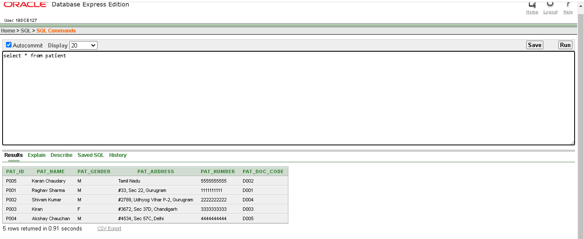

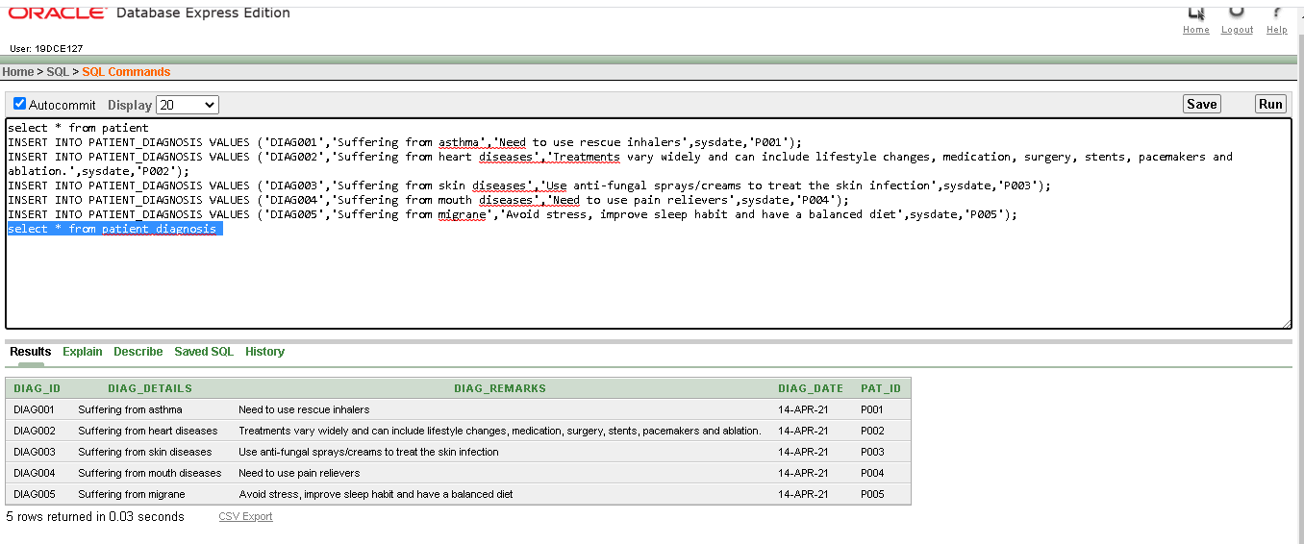

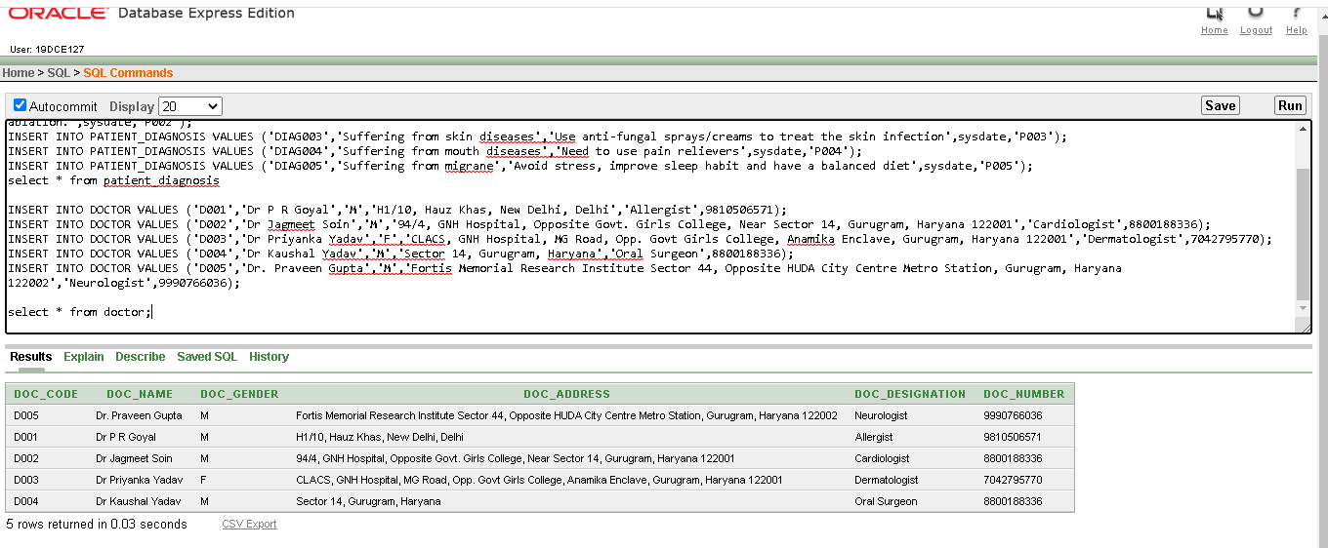

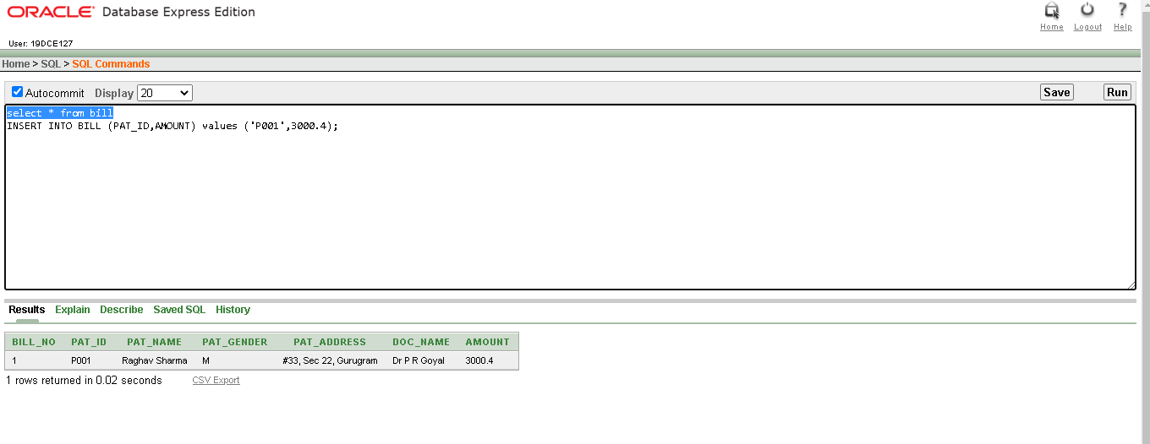

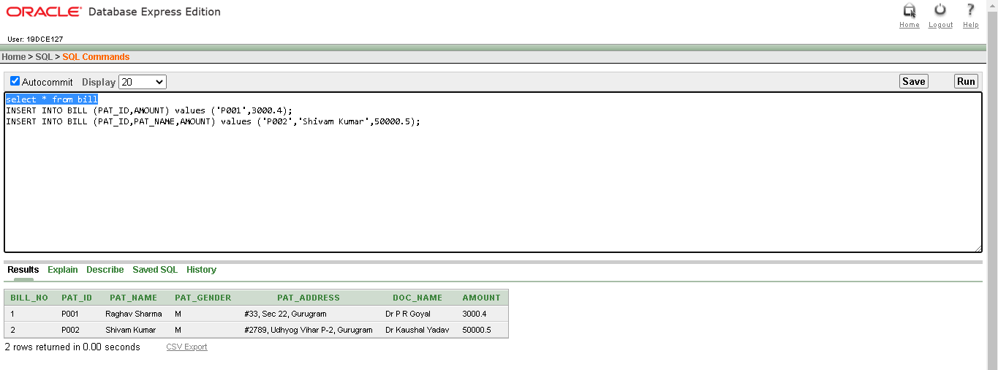

ER diagram:

